**Practical 1 :- Creating and Managing Vector Data.**

1. **Creating Polygon Vector Layer**

**Polygon:- It is used to display larger areas like gardens , water bodies , houses etc .**

1. Click on layer --> Create Layer -->New Shapefile Layer

2.Give filename(area name.shp),Geometery type = Polygon

3.Add new field (name)

4.Click Ok .

5.Click on pencil and create shape of our choice and then give it id , name.

you can change Colour using properties.

6. Add more layers according to your need.

1. **Creating Line Vector Layer**

**Line :- It is used to display roads , railways ,highways etc .**

1. CLick on layer --> Create Layer -->New Shapefile Layer

2.Give filename(area name.shp),Geometery type = LineString

3.Add new field (name)

4.Click Ok

5.Click on pencil and create shape of our choice and then give it id , name

you can change Colour using properties

6. Add more layers according to your need

7. right click on road routes --> symbology --> advanced --> tick on symbol layers so that roads merge together.

8. To make labels visible --> properties --> labels

1. **Creating Point Vector Layer**

**Point :- It is used to display small areas like hospitals , temples , hotels etc .**

1. CLick on layer --> Create Layer -->New Shapefile Layer

2.Give filename(area name.shp),Geometery type = Point

3.Add new field (name)

4.Click Ok

5.Click on pencil and create shape of our choice and then give it id , name

you can change Colour, using properties

6. Add more layers according to your need.

**Output :-**

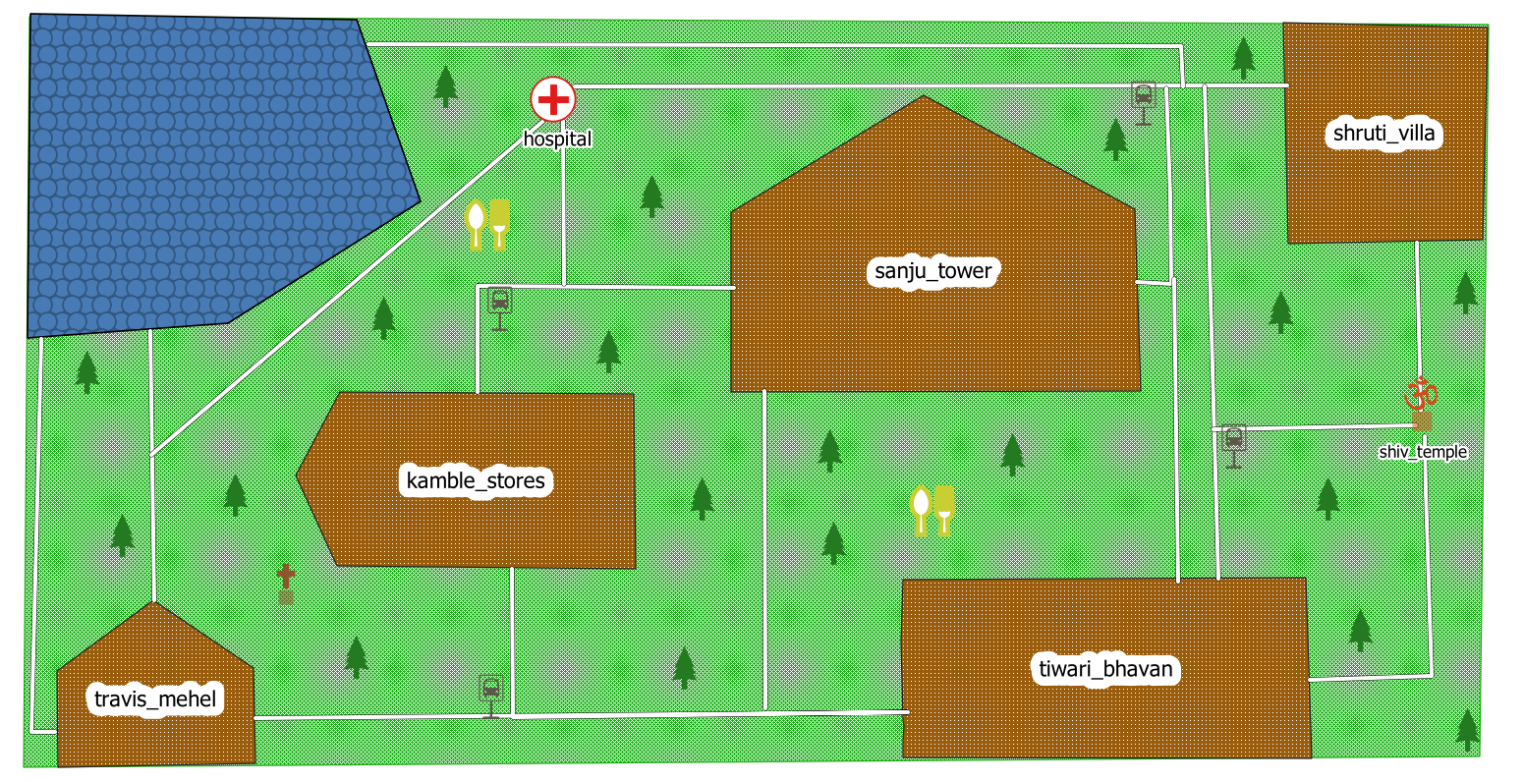

1. **Calculating line lengths and statistics .**

**Steps :-**

1. Layer--> Add Layer --> Add Vector Layer

2. We have to add railways route --> select file from dataset (IND_rails.shp) --> Add & close

3.Next again add layer --> Select file (IND_adm0.shp) --> Add and Close .

4.Right click on Ind_adm0 --> Properties --> Symbology --> outline --> Apply & ok

5.Right click on Ind_rails --> Open Attribute table --> click on pen

6.Select open field calculator --> add new field --> Name(Route_len) , type (Decimal No.),Precision (2)

7. select Geometry --> write expression --> $length/1000 --> Ok

8. new column created route_len --> Save

9.Vector --> Analysis Tools --> Basic Statistics for Fields --> field to calculate statistics on --> route_len --> run

8.Right click on Ind_rails --> Properties --> labels --> single labels -->

value (route_len --> Apply

9. right side panel --> their is a link below results viewer --> click on that link it will open html file.

**Output :-**

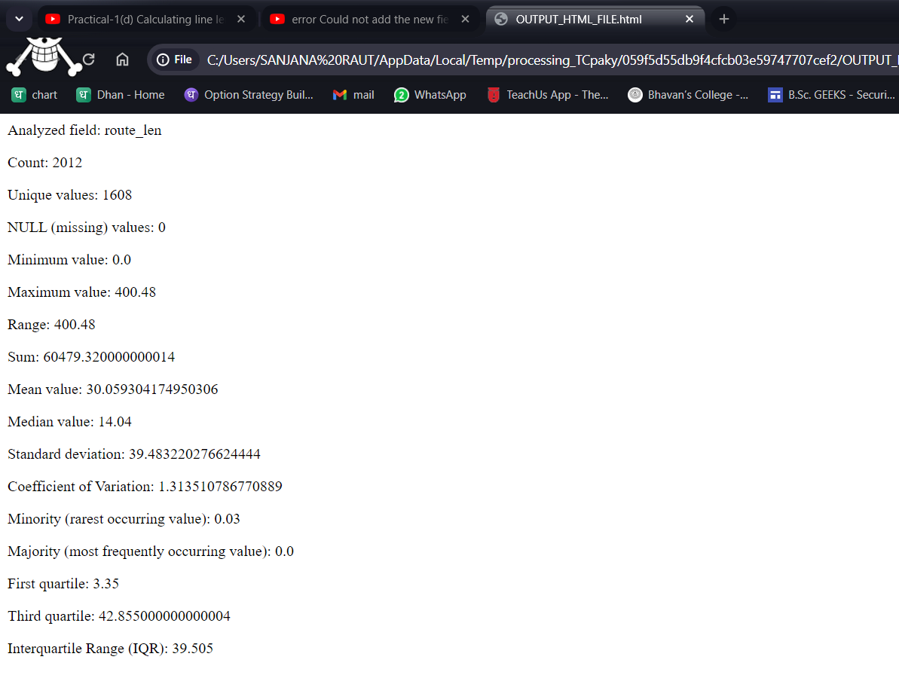

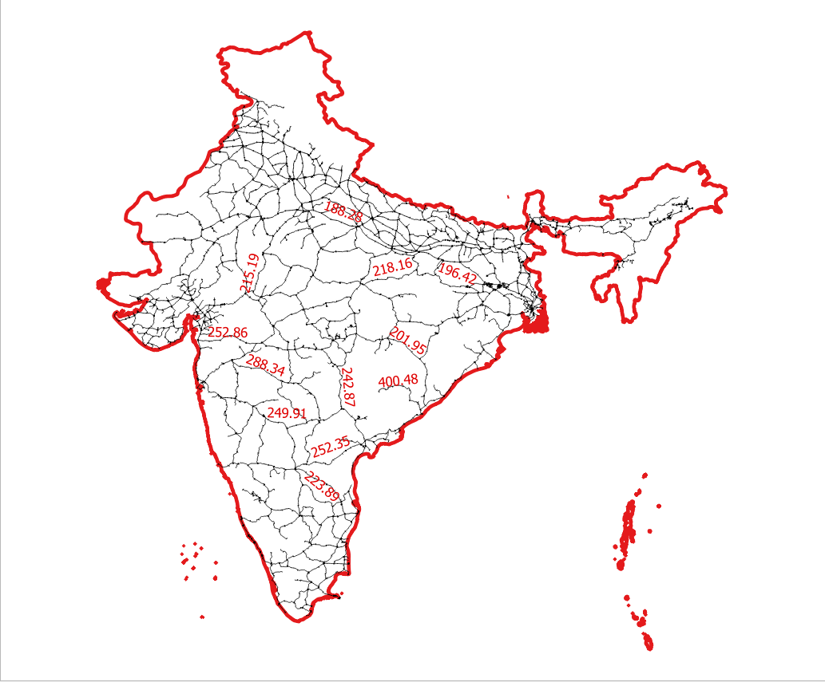

**Practical 2 :- Exploring and Managing Raster Data.**

1. **Adding Raster Layers**

**Steps:**

1. Layer --> Add layer --> Add Raster Layer --> select files

1. glds90ag60.asc

2. glds00ag60.asc

1. **Raster Styling and Analysis**

**Steps**

1. select layer1 (glds90ag60.asc) --> properties --> symbology

Render type :- Singleband pseudocolor, Interpolation:-Linear

min :- 0 , Max:- 240

color ramp :- select color --> apply & ok

2. same for the layer2 (glds00ag60.asc)

3. raster --> raster calculator --> output layer (population_difference)--> expression

("glds00ag60@1"-"glds90ag60@1") --> Output CRS(WGS 84) --> ok

4. deselect layer 1 and 2 and only select population layer

5. right click on population_difference layer

Render type :- Singleband pseudocolor, Interpolation:- Discrete

min :- -20000 , Max:- 6000

color ramp :- select color

6. select all values and click on minus sign

7. now add values using plus sign

values Label

1. -20000 NO DATA

2. -10 NEGATIVE

3. 10 NEUTRAL

4. 6000 POSITIVE

(Choose color according to your preference)

**Output :-**

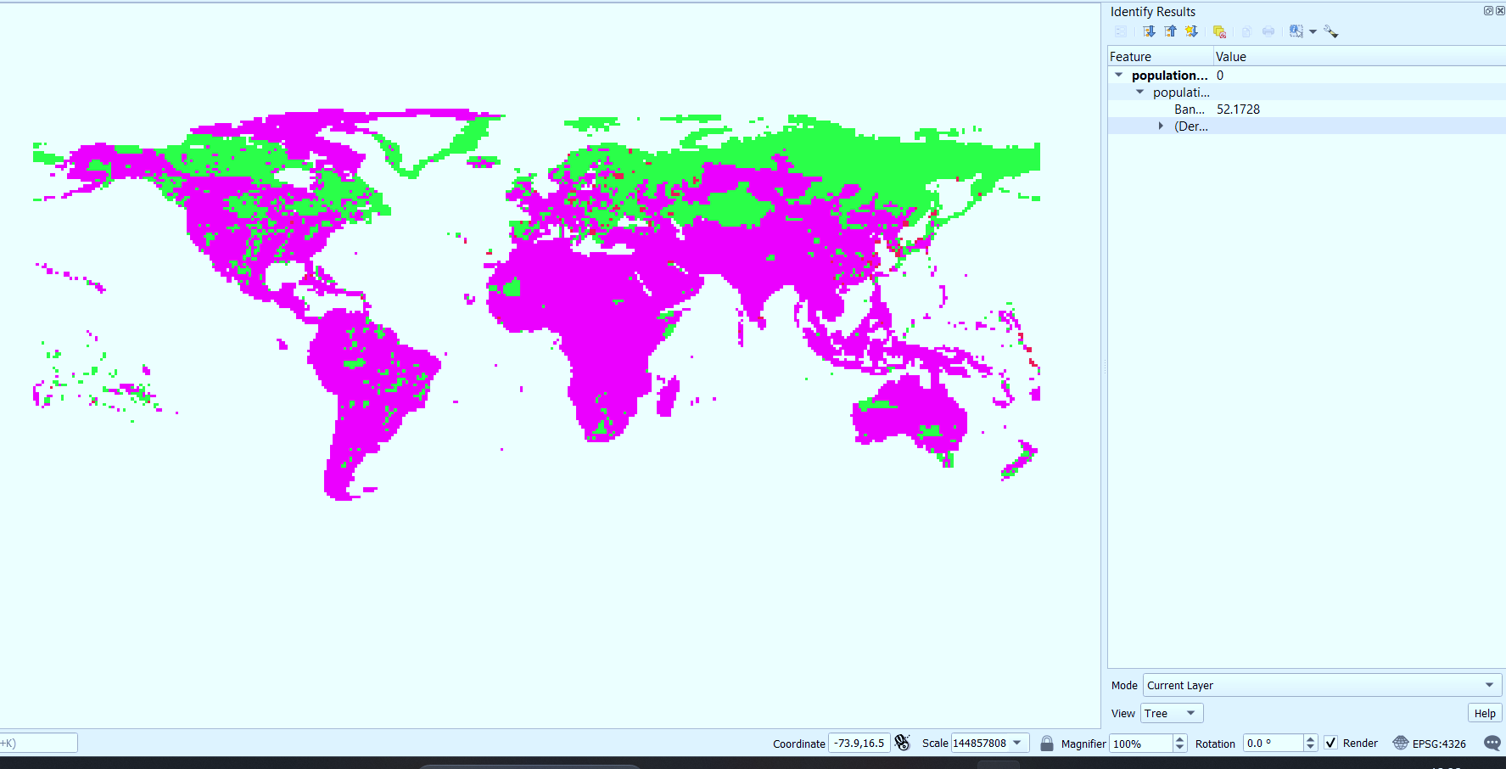

1. **Raster Mosaicking and Clipping**

**Steps:-**

1. Go to Layer → Add Layer → Add Raster Layer.

2. Select the following “.tif” raster images for India from data folder.

FAS_India1.2018349.terra.367.2km.tif

FAS_India2.2018349.terra.367.2km.tif

FAS_India3.2018349.terra.367.2km.tif

FAS_India4.2018349.terra.367.2km.tif

3.Press open

4.In data source manager | raster window click Add.

5.Go to Raster → Miscellaneous → Merge

6.In the Merge dialog window.

7.Select all layers and Press OK.

8.In Merge dialog window select a file name and location to save merged images.

Save the file to “GIS_Workshop/Practicals/Practical_02/C/” location with the name as

Merge_Files.tif

9.Press Run and after completion of operation close the Merge window dialog box.

10. deselect individual layers and only keep merged raster file .

11.Go to Layer→ Add Vector Layer → Select (IND_adm0.shp) file.

12.From layer properties → select symobology → select any one of the outline

13. Go to Raster → Extraction → Clip Raster by Mask Layer

14.Select the merge raster image as input and Ind_adm0 as mask layer.

15.Select a file name and location for clipped raster

16. Press Run

**Output :-**

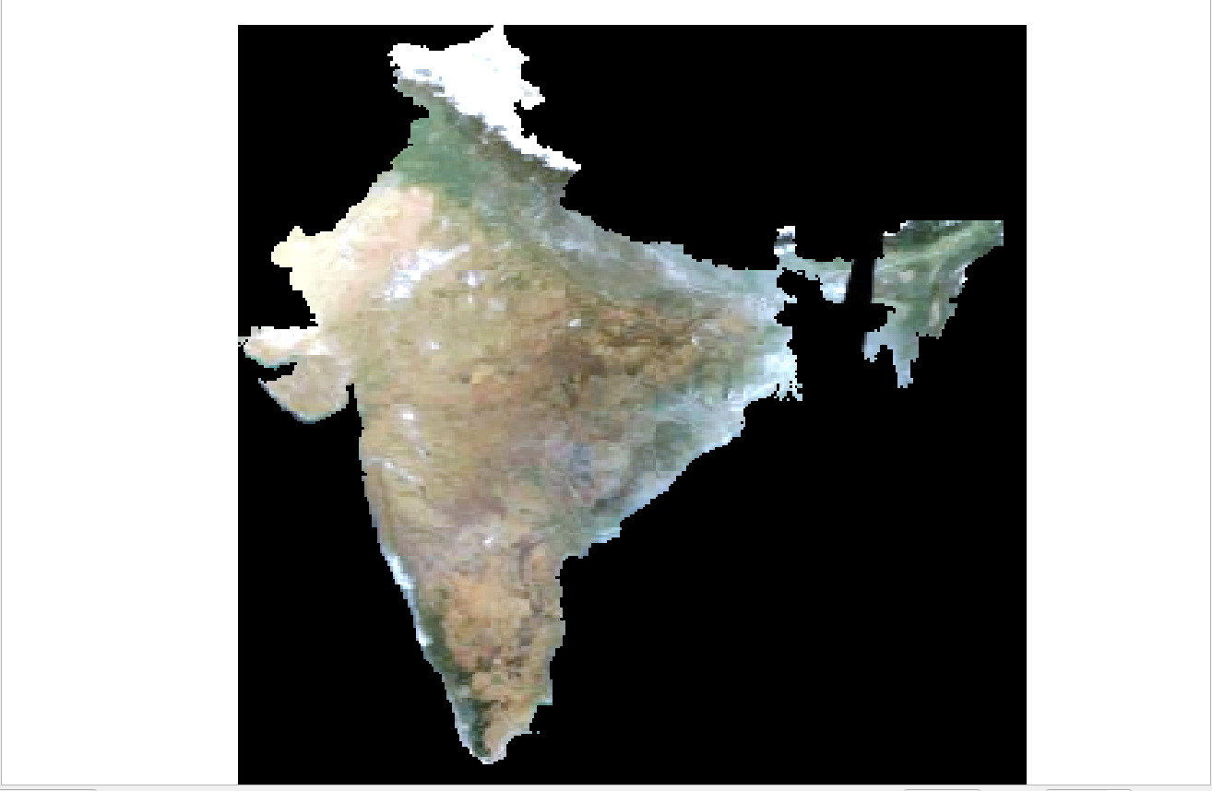

**Practical 3:-**

1. **Making Map**

**Steps :-**

1. Layer 🡪 add Vector layer 🡪 select file (IND_adm1.shp) 🡪 Add
2. Add all files with (.shp) extension that are present in folder .
3. IND_adm1 🡪 set properties 🡪 outline border
4. Maharashtra_poi 🡪 change colour = red
5. Project 🡪 New Print Layout 🡪 name it
6. Add item 🡪 add map 🡪 select the whole white part
7. Item Properties 🡪 lock layers & lock style for layers
8. Zoom the map on Mumbai part
9. Again add map and select the area you want to place the map
10. Map 1 🡪 Item Properties 🡪 Overview🡪 Plus 🡪 Map Frame (Map 2)
11. Map 2 🡪 Item Properties 🡪 frame
12. Add Item 🡪 Add Label 🡪 Mumbai Map (change colour , font)
13. Again Add label 🡪

<h2> &copy; COPYRIGHT RESERVED </h2>

<h1> Your name </h1>

* Render as html 🡪 change colour

1. Add Item 🡪 Add Legends
2. Add Item 🡪 Add Scale bar 🡪 Item Properties🡪 Segments (left 0 , right 10)
3. Add Item 🡪 Add North arrow
4. Layout 🡪 Export as Image 🡪 save

**Output :-**

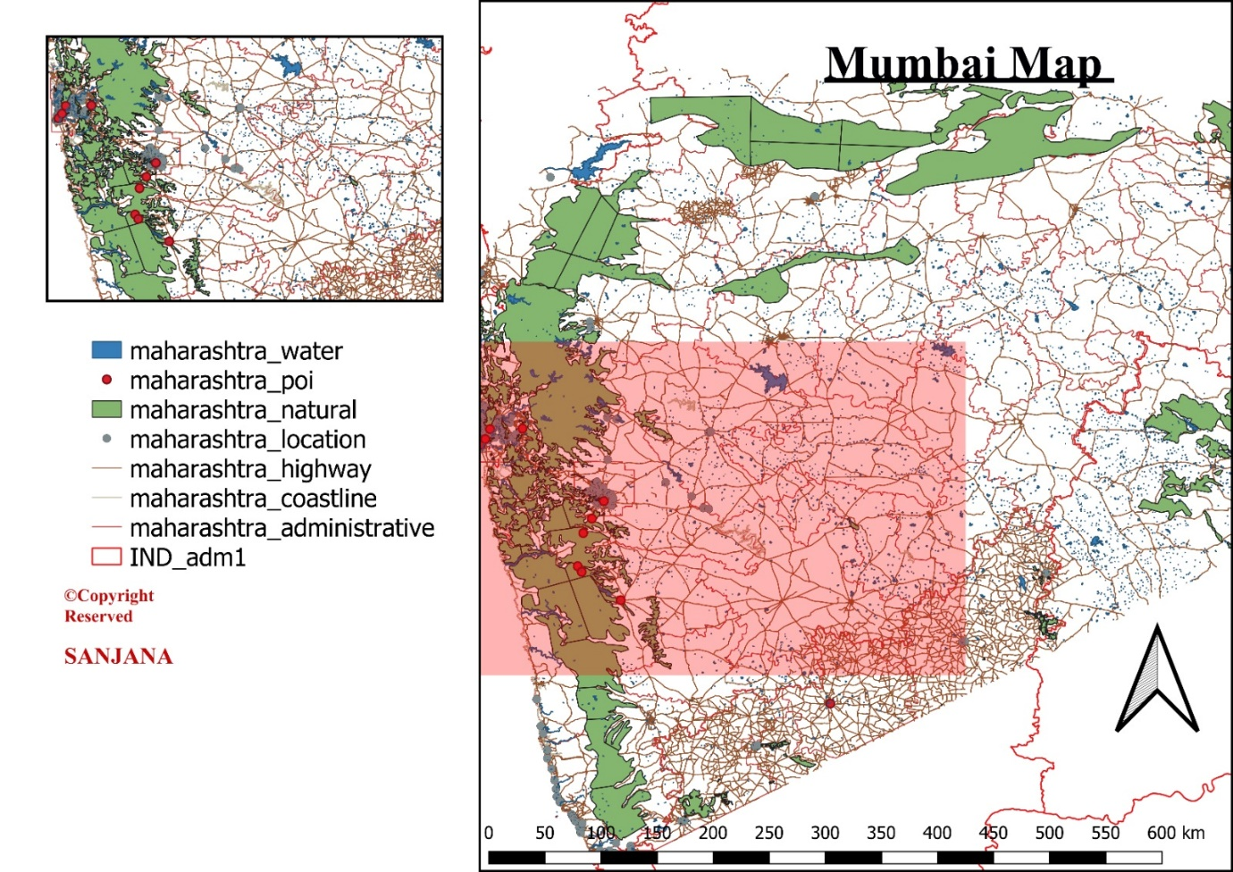

1. **Importing Spreadsheets or CSV files**

Step 1. Go to Layer → Add Layer → Add Delimited text Layer

Step 2. Select the \GIS_Workshop\Practicals\Practical_03\C\Sample.csv file from data folder.

Step 3. Press ADD and close the window.

**Output :-**

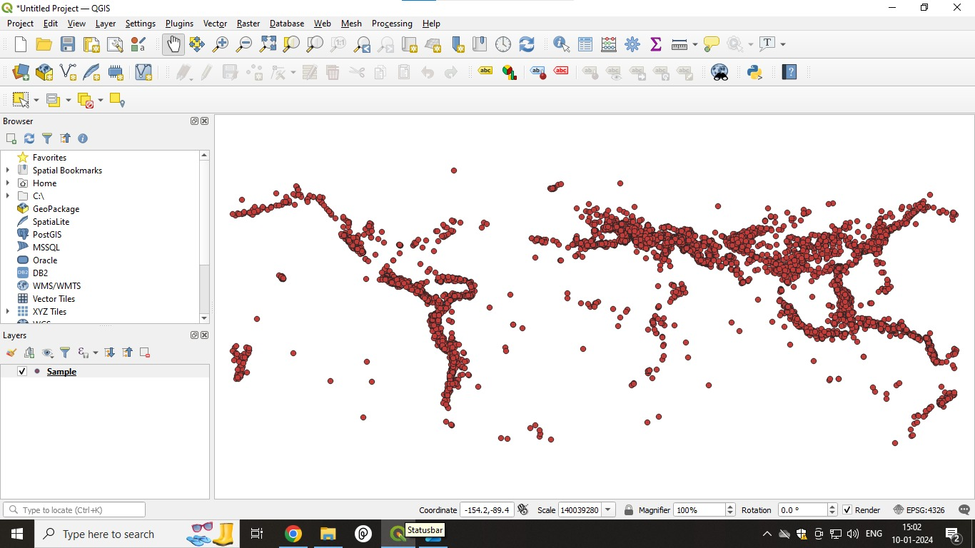

1. **Using Plugins**

Step 1. Open QGIS. Click on Plugins → Manage and Install Plugins

Step 2. To enable a plugin, check on the checkbox next to Plugin. This will enable the plugin to use it.

Step 3. External plugins are available in the QGIS Plugins Repository and need to be installed by the users before using them

Step 4. Click on Not Installed or Install from ZIP.

Step 5. Once the plugin is downloaded and installed, you will see a confirmation dialog

Step 6. Click on Plugins → <<new Plugin name>>

Step 7. The Plugin if marked Experimental plugin can be installed, from Setting→ check on ‘Show also experimental plugins’ or ‘Show also deprecated plugins’

Step 8. A tab will be added to Plugin Manager Window.

Step 9. Click on a plugin name and Click Install.

1. **Searching and Downloading OpenStreetMap Data**

Step 1. Add “Open Layer” and “OSM Search” Plugin from Not Installed option from Plugin Manager Dialog Box.

Step 2. The OSM Place Search plugin will install itself as a Panel in QGIS, if not go to View → Panels → select OSM Place Search.

Step 3. Go to Web → OpenLayers Plugin and select Open Street Map. A World map will appear on screen.

Step 4. In OSM Place search Pane → Enter Mumbai or any place name to search

Step 5. Double click on the desired place in OSM Place search Panel or Click and press

**Output :-**

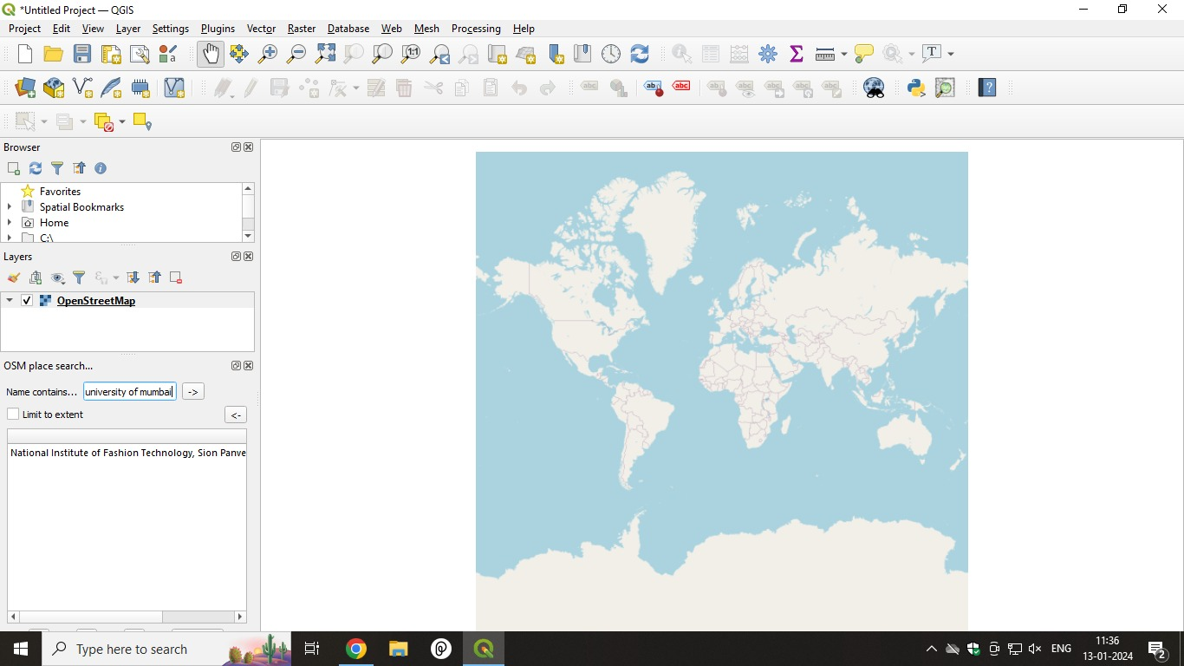

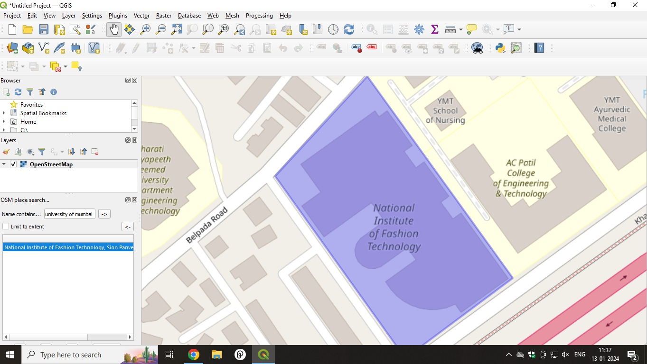

**Practical 4:-**

1. **Working with attributes**

**Steps:-**

1.Start a new project.

2.Go to Layer → Add Layer → Add Vector Layer

3.Select“\GIS_Workshop\Practicals\Practical_04\A\Data\ne_10m_populated_places_simple.zip”

4.Right click on Layer in Layer Panel → Open Attribute Table

5.Explore various attributes and their values in the Attribute table.

6.To find the Place with maximum population click on “pop_max” file

7.On clicking the Select feature using expression button the following window will appear

8.Enter pop_max>100 and pop_max <10000 and click select features button to get all the places with population between 100 and 10000.

9.The places matching the criteria will appear in different color.

10. Different queries can be performed using the dataset.

**Output :-**

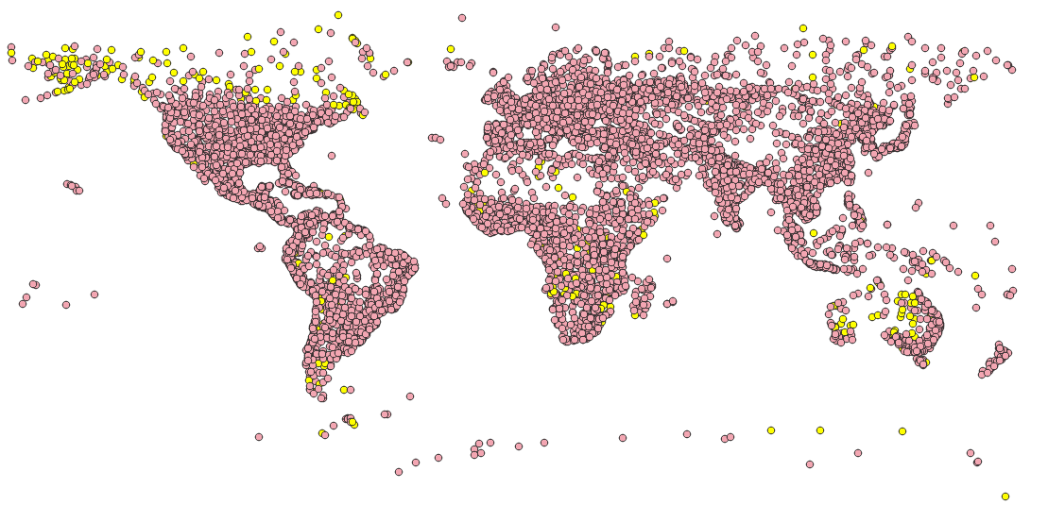

1. **Terrain Data and Hill Shade Analysis .**

**Steps:-**

1. Go to Layer → Add Raster Layer → select “10n060e_20101117_gmted_mea300.tif”, from Data folder
2. Enter 86.92, 27.98 in the coordinate field, Scale 900000 and Magnifier 100% at the bottom of QGIS.
3. Crop the raster layer only for the region under study.
4. Go to Raster → Extraction→ Clip Raster by Extent.
5. Clipping extent 🡪 use Map Canvas extent 🡪 Run .
6. Deselect the original layer and keep the clipped one.
7. Go to Raster → Extraction→ Contour
8. Select the input raster layer name. Set contour interval 100.00 meters, select the output file name & location and check the option to add output file to project after processing.
9. Press “RUN”.
10. Add label to layer 🡪 “ELEV” field and set appropriate symbols for line.
11. For Hill Shade surface analysis
12. Go to Plugin → Install Georeferencer GADL.
13. After successful installation of plugin Go to Raster → Analysis → Hill Shade.
14. Select the input raster layer, select file name and location for storing Hill Shade output file.

**Output :-**

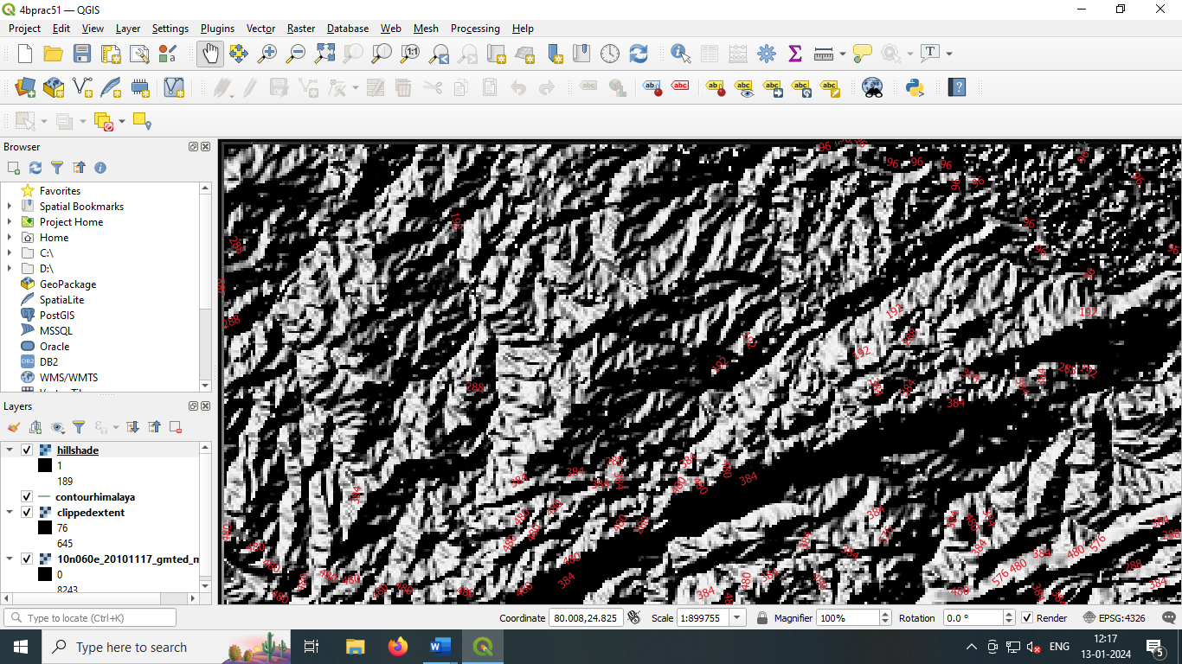

**Practical 6 :-**

1. **Georeferencing Topo Sheets and Scanned Maps**
2. Start a new project
3. Go to Layers → Add Layer → Add vector Layer
4. Select GIS_Workshop\Manual\Prac06\IND_adm0.shp
5. Zoom in to Mumbai region in the layer.
6. Go to Plugins 🡪 Manage and Install Plugins
7. Ensure that Geoference GDAL is Checked , if not install Geoference GDAL plugin.
8. Go to Raster 🡪 Geoferencer
9. A new Georeferencer window will open
10. File → Open Raster
11. Select file “1870_southern-india_3975_3071_600.jpg” from project data folder
12. Go to Settings →Transformation Settings
13. In the Transformation Settings window
14. Select Transformation type → Thin Plate Spline
15. Re-sampling Method → Nearest Neighbour
16. Target TRS → Everest 1830 datum: EPSG 4044
17. Select Output Raster Name and Location
18. Check the Load in QGIS When Done Option 🡪 Press “OK”.
19. In Georeferencer window Go to Edit → Add Points
20. Click on the raster to add control points and select “From Map Canvas” button
21. Select the set of control points 🡪 Go to, Setting → transformation settings.
22. Press “RUN” 🡪 In Georeferencing window go to → File → Start Georeferencing
23. The canvas area will now have the scanned map of Mumbai referenced with control points.
24. Select the newly added layer in Layer Panel Right click and go to property.
25. Set Transparency level of raster layer to appropriate level.

**Output :-**

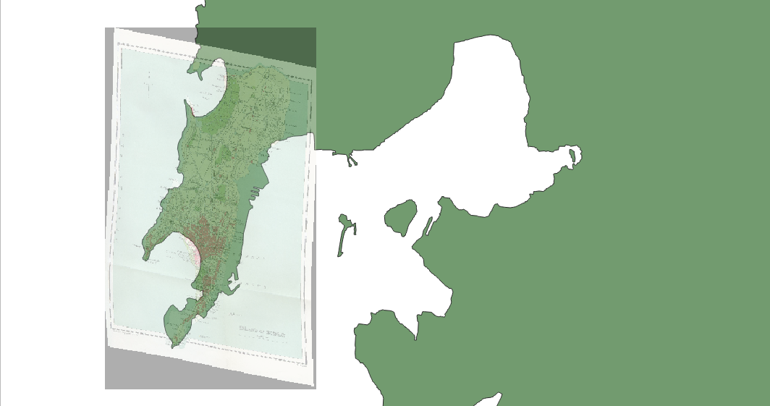

1. **Georeferencing Aerial Imagery**

**Steps :-**

1. Install plugin OpenStreetMap
2. Go to Web Menu → OpenLayerPlugin → OpenStreetMap→ OpenStreetMap
3. Go to Project → Properties → Set CRS to EPSG 3857
4. Go to View → Panels → select OSM Place search
5. The Gateway of India, Mumbai is located at 18.92 N 72.83 E
6. Search Gateway of India in OSM Search Panel
7. Zoom in to appropriate level.
8. Go to Raster → Georefrencer
9. A new Georeferencer window will open
10. File 🡪 OpenRaster
11. Select file “Gateway_Imagery.tif” from project data folder
12. Go to Edit → Add Point 🡪 Select control points from map (Indicated in red color).
13. Go to File → Start Georeferencing or Press the play button in Georegerencing Window.

**Output:-**

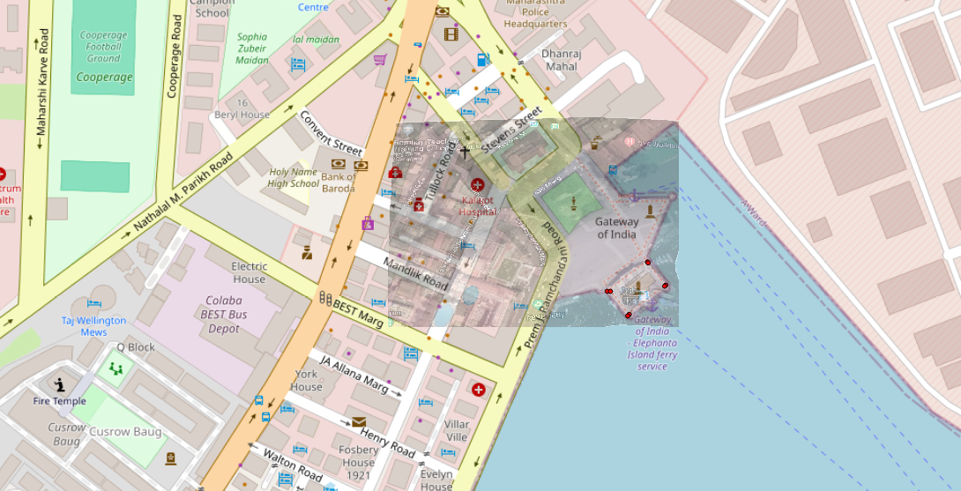

**Practical 7 – Managing Data tables and Spatial data sets.**

1. **Table joins**

**Steps –**

1. Go to layer > Add Layer > Add Vector Layer
2. Select ‘nybb.shp’ file > click on Add
3. Select another file ‘OEM_NursingHomes_001.shp’ file > click on Add.
4. Go to Vector > Data Management Tools > Join Attributes by Location.
5. Within the base layer, select nybb and within join layer select OEM_NursingHomes_001.
6. Within fields to add > click on three dots > choose ‘select all’ option > click on ok.
7. Within Join type select ‘Take attributes of the first matching feature only (one to one)’ > Click on run > after finishing click on close.
8. On the left side, in layers tab, deselect the OEM_NursingHomes_001 and nybb layers
9. From the icons on the upper side click on *i icon.*
10. Select the OEM_NursingHomes_001 layer then using that *i* button we can click on any part of map.

**Output –**

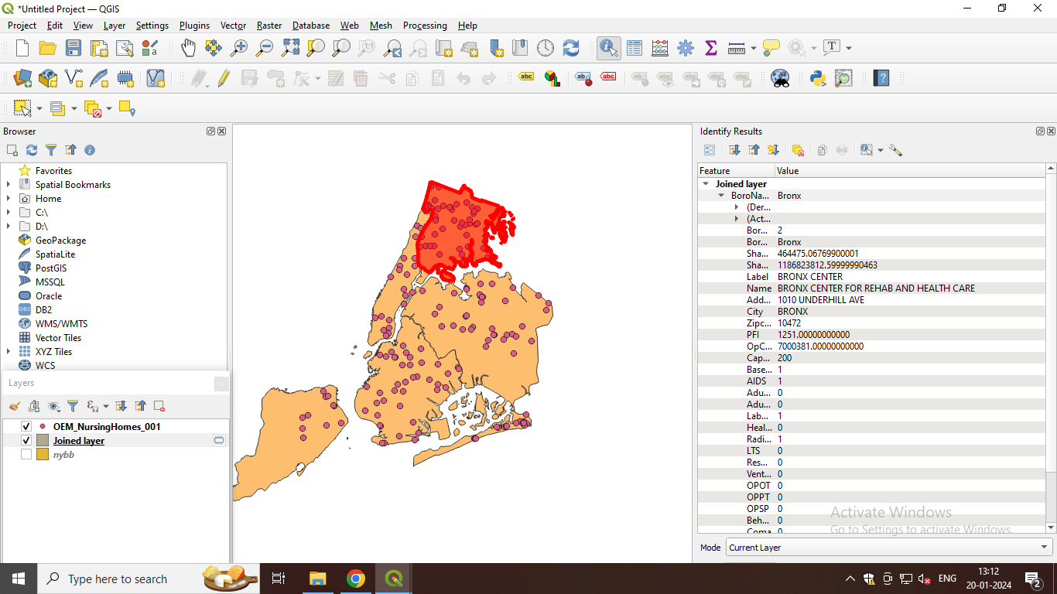

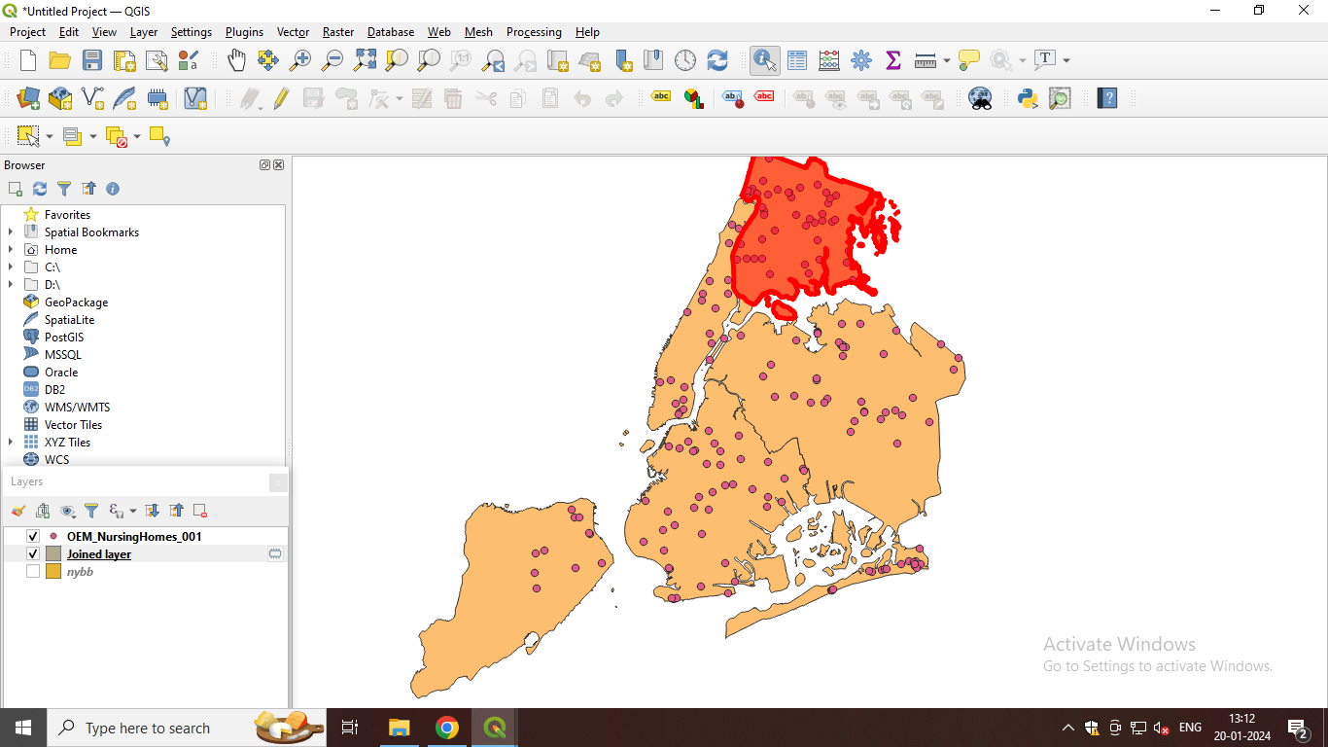

We can see the attribute table of joined layer and find that joined operation is performed because both attributes of nybb and OEM_NursingHomes_001 are joined.

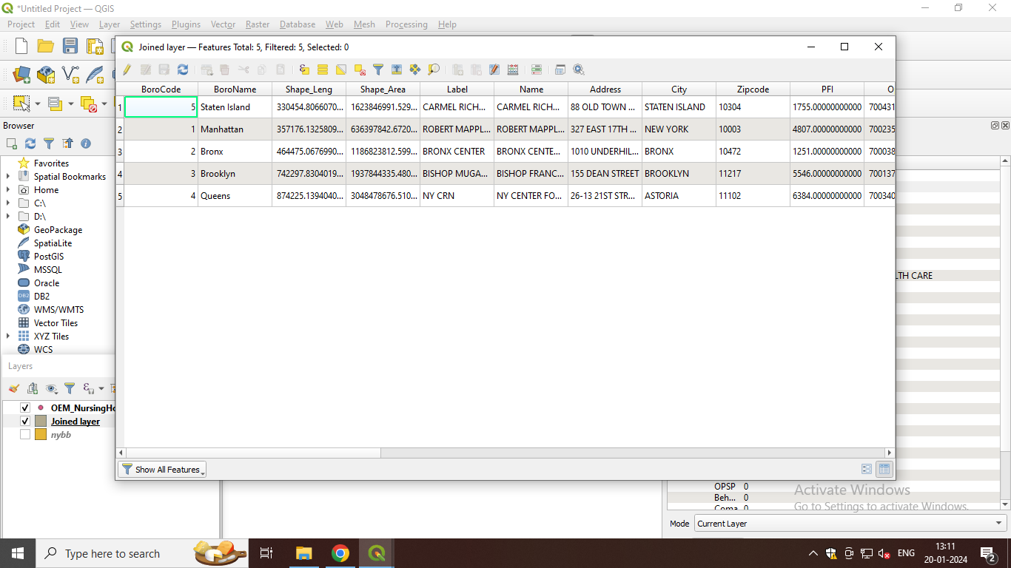

1. **Points in polygon analysis**

Steps –

1. Go to layer > Add Layer > Add Delimited Text Layer
2. In the file name, select ‘EarthQuakeDatabase’ > click on add > click on close.
3. Go to layer > Add Layer > Add Vector Layer > select ‘ne_10m_admin_0_countries.zip’ file > click on add and close.
4. Go to Vector > Vector Analysis > Count points in polygon.
5. Within polygon choose ne_10m_admin_0_countries and within points select earthquake.
6. Within count, type earthquake_counts > click on 3 dots > save to file > give the file name as ‘earthquake_count.gpkg’ > save > click on run > close
7. Zoom in to India > Click on the *i* button > click on India.

When clicked on India, we can see earthquake prone areas. For India, we can see numpoint is 70, for South Africa we see 11 meaning it tells us the earthquake prone areas. We can click on any area and know the earthquake prone areas.

**Output :-**

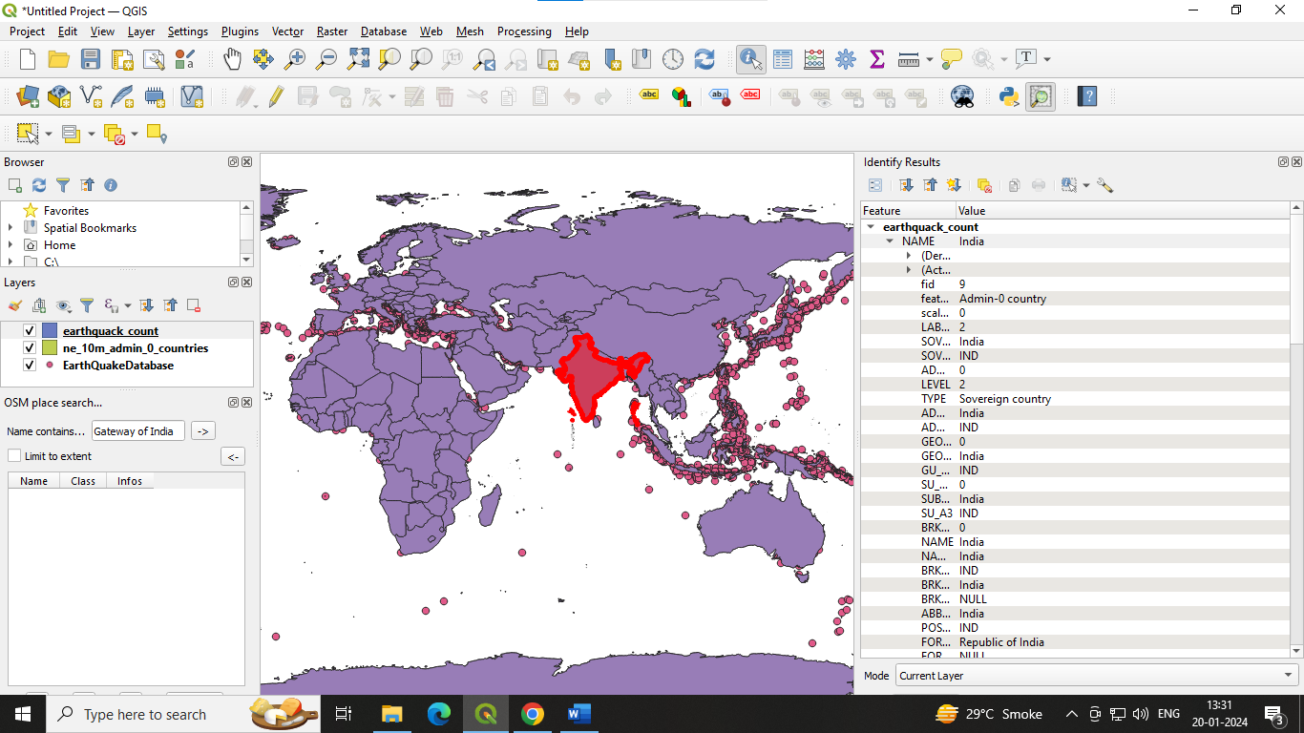

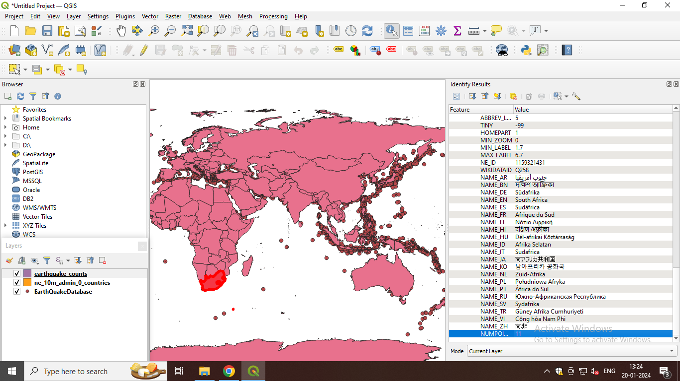

1. **Performing spatial queries.**

Steps –

1. Go to layer > Add Layer > Add Vector Layer > select ‘ne_10m_populated_places_simple.shp’ file > add
2. Select another file ‘ne_10m_rivers_lake_centerlines.shp’ file > add
3. Change the color of the river lake layer. Right click on ne_10m_rivers_lake_centerlines layer > properties > within symbology select topo hydrology > apply > ok.
4. Go to Project > Properties > CRS > type in the filter tab ‘54032’ > select ‘World_Azimuthal_Equidistant’ wIth authority id ‘ESRI:54032’ > apply> ok
5. Go to Vector > Geoprocessing Tools > Buffer.
6. Within input layer select ne_10m_rivers_lake_centerlines
7. Within distance type 0.02 > click on Run.
8. Change the colour of populated places. Right click on ne_10m_populated_places_simple > properties > symbology > choose brown.
9. Go to Vector > Research Tools > select by location.
10. Within select features from select Buffered > click on Run.
11. Give the label. Right on rivers layers > properties > labels > select Single labels > apply > ok.

Output –

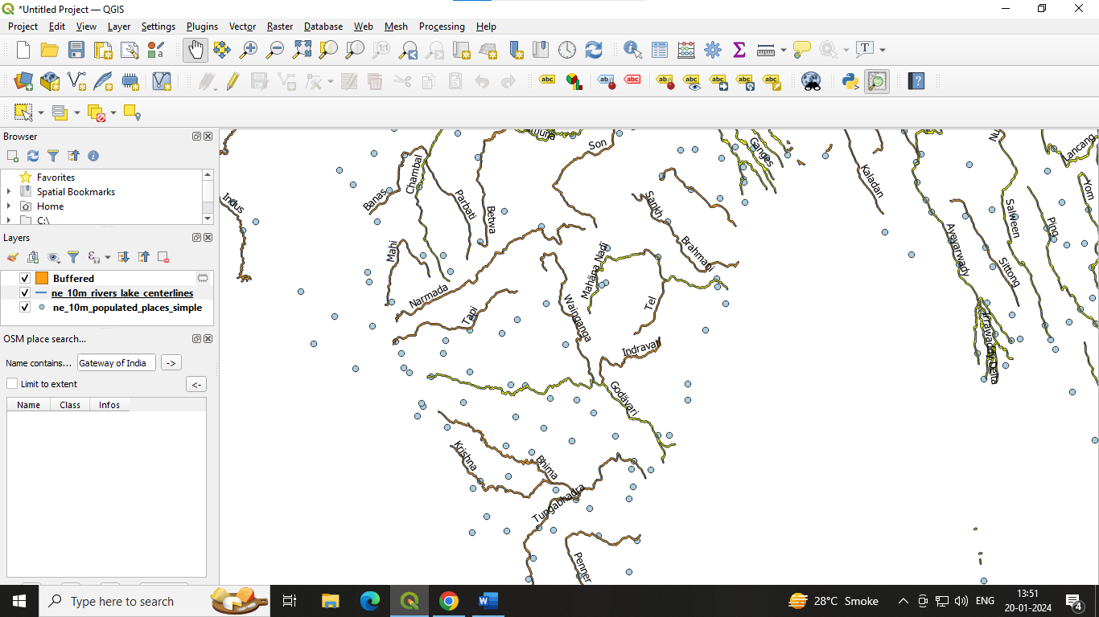

On zoom in, we can see the yellow-coloured rivers in the map like Godavari, Mahana Nadi we can say that within 2 km range they are most populated.

**Practical**

**Working with Projections and WMS Data**

A Web Map Service (WMS) is a standard protocol developed by the Open Geospatial Consortium in 1999 for serving georeferenced map images over the Internet.

These images are typically produced by a map server from data provided by a GIS database

Step 1: Start a new Project. Layer → Add Layer →Vector Layer

Step 2: Select “ne_10m_admin_0_countries.zip” Layer from data folder.

Step 3: Go to Layer → Save As Select format as ESRI Shape File

Select folder location and file name Set CRS North_America_Albers_Equal_Area_Conic EPSG: 102008

Step 4: Select Layer → Add Layer → Add Raster Layer → Select MiniScale_(standard)_R17.tif from Location

Step 5: Open Layer Properties→CRS → Search bri → select British National Grid EPSG 27700. ➢ Processing may take some time.

Locate United Kingdom on Layer; the vector layer exactly coincides by the raster layer covering United Kingdom.

**Output:**

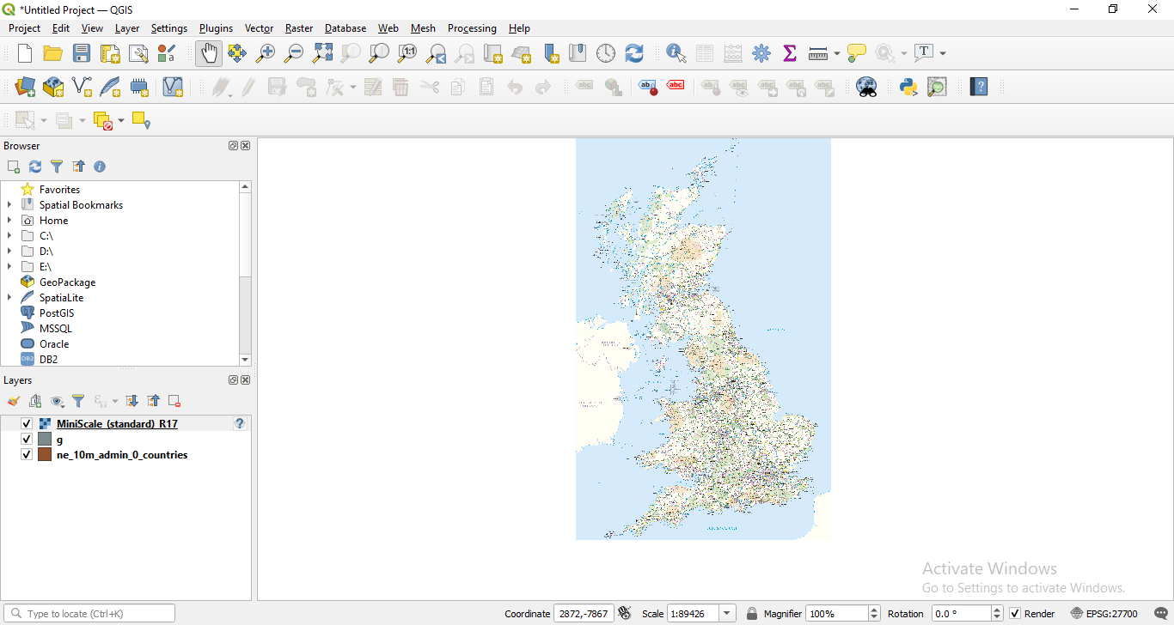

**Practical**

**Advanced GIS operations**

1. **Nearest Neighbor Analysis**

GIS is very useful in analyzing spatial relationship between features. One such analysis is finding out which features are closet to a given feature. QGIS has a tool called Distance Matrix which helps with such analysis.

Step 1:

Go to layer tab – Add layer – Add vector layer

Select vector dataset as -ne_10m_populated_places_simple.shp click on add.

Step 2:

Go to layer tab – Add layer – Add delimited text layer

Select vector dataset as -earthquakedatabase1.tsv file click on add.

Step 3:

Right click on earthquakedatabase – click on open attribute table you will see some null values

Step 4: Go to processing tab – toolbox – vector geometry – select remove null geometrics. Select the option also remove empty geometrics click on run.

Step 5:

Go to processing tab – toolbox – vector analysis – Distance to Nearest Hub (Line to Hub)

**Output:**

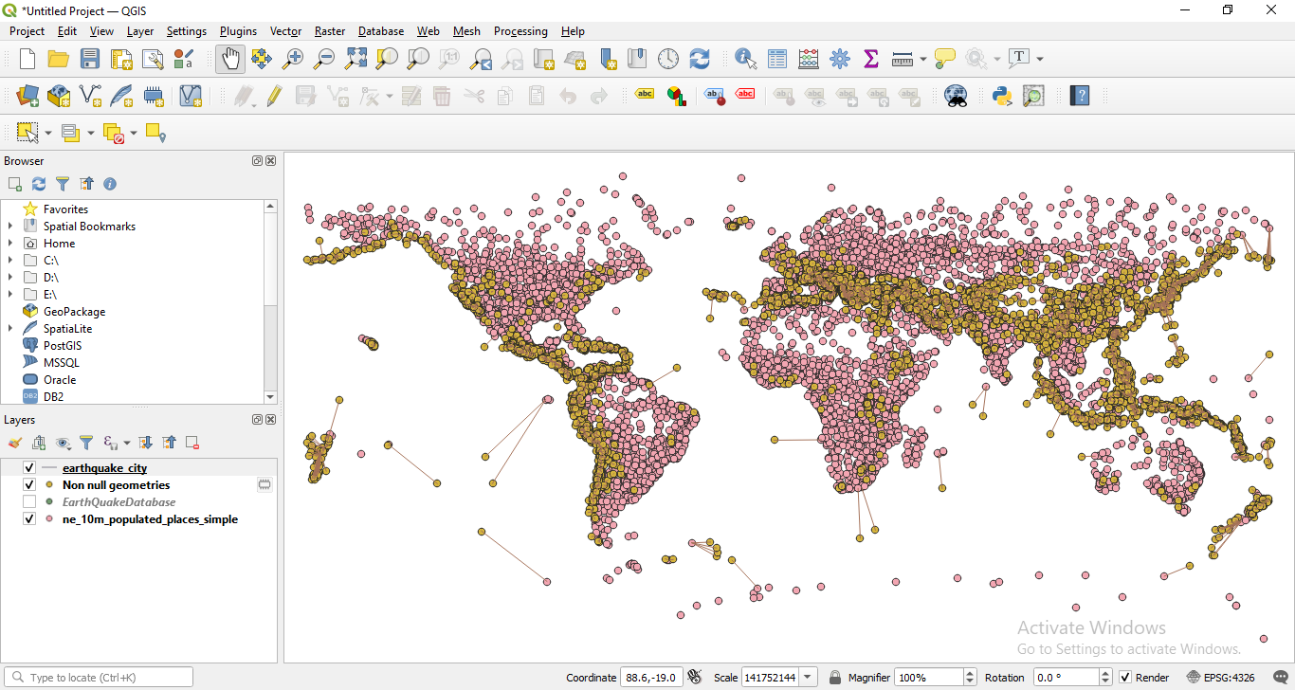

1. **Sampling raster data using points and polygon**

Step 1:

Go to layer tab – add layer – add raster layer

In the data sets select this image - us.tmax_nohads_ll_20140525_float click on add.

Step 2:

Go to layer tab – add layer – add delimited text layer

In the data sets select - 2013_Gaz_ua_national click on add.

Step 3:

Go to processing tab – toolbox – raster analysis – double click on sample raster values.

Now for doing sampling data using polygon remove the sampled and 2013 us national layer.

Step 4:

Go to layer tab – add layer – add vector layer

In the data sets select tl_2018_us_county.shp click on add.

Step 5: Go to processing – toolbox – zonal statistics (search)

Click on statistics three dots and select only mean value and then run.

Go to properties there will be new column mean is added into the attribute table.

**Output:**

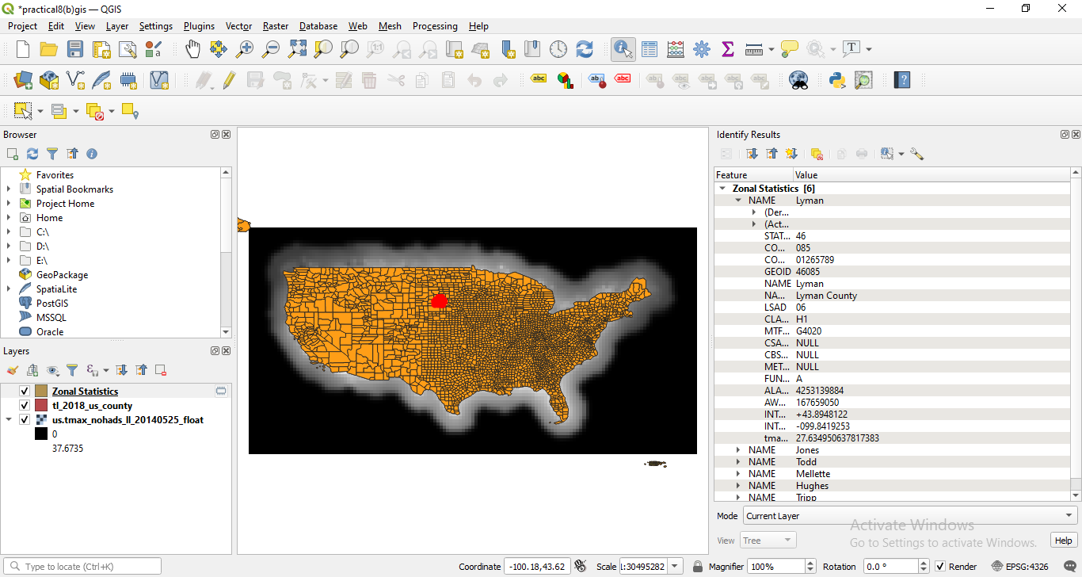

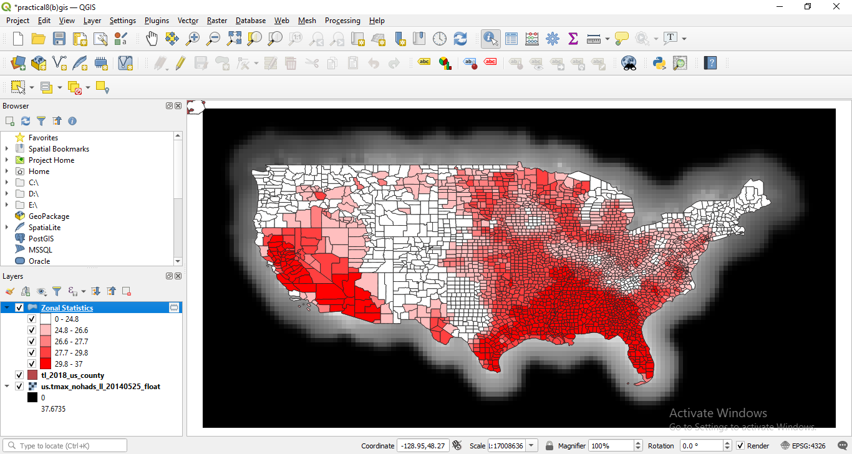

1. **Interpolating Point Data**

Interpolation is a commonly used GIS technique to create a continuous surface from discrete points. In QGIS, interpolation is achieved using the built-in interpolation tools from the processing toolbox.

Step 1:

Go to layer tab – add layer – add vector layer

In the data sets select - Arlington_Surroundings_2007_stpl83 click on add.

Step 2: Go to layer tab – add layer – add vector layer

In the data sets select - Boundary2004_550_stpl83.shp click on add.

Step 3: Go to layer tab – add layer – add vector layer

In the data sets select - Islands_2004_550_stpl83.shp click on add.

Step 4: Go to processing tab – toolbox – interpolation (search) – TIN interpolation

Step 5: Go to processing – toolbox – GDAL – raster extraction – clip raster may mask layer.

Right click on clip and then go to symbology.

Click on classify and then ok.

Step 6: In the processing -toolbox -GDAL – raster extraction- select contour

Go to the properties of contour

**Output:**

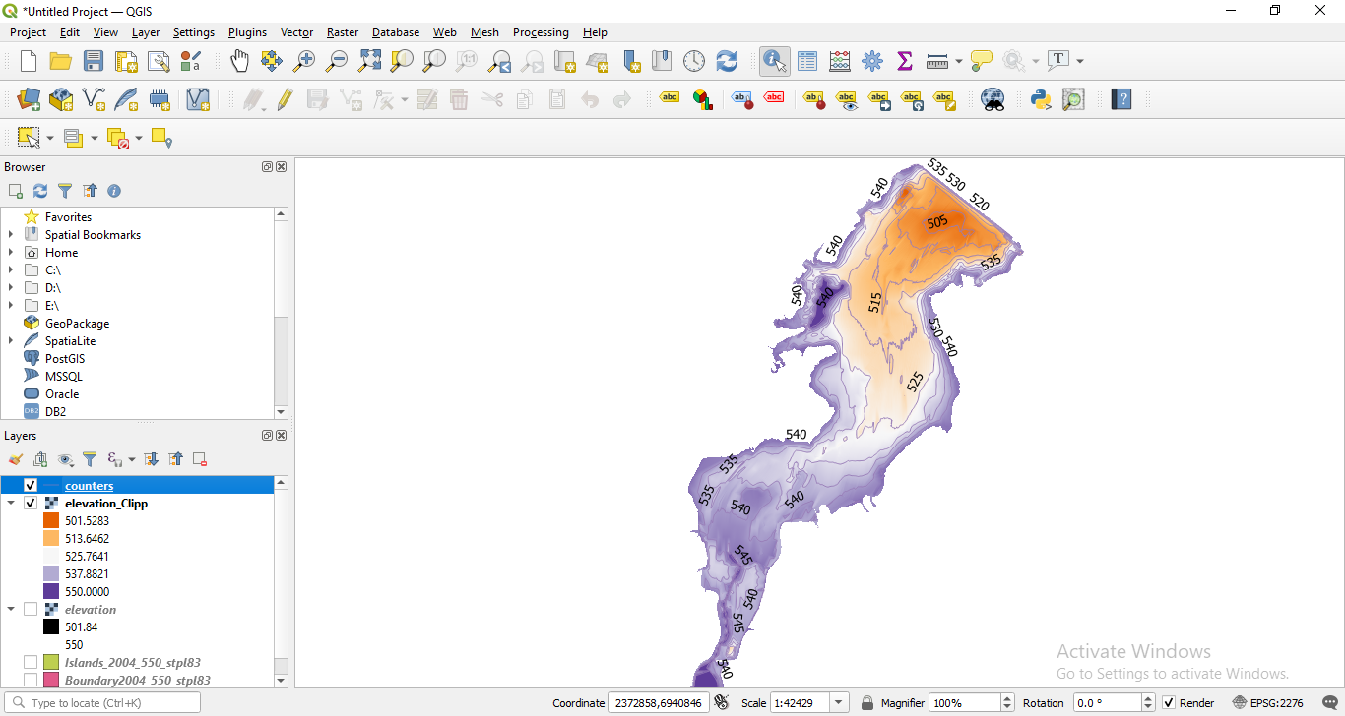

**Practical**

**Validating map data.**

Step 1: Open Kenya_epidemicological_data.xls in excel. Go to view tab, click freeze panes and choose freeze top row.

Step 2: Select the entire “child_id” column. Under home tab, click on conditional formatting – highlight cell rules – select duplicate values.

Now select the first combo box and select Duplicate and select Light red fill with Dark red text in the next combo box.

Step 3: Removing Duplicates Select all the columns of existing worksheet Now go to Data Tab and select Remove Duplicates

Step 4: Coding of variables In the current worksheet, select the sex column. Now type Ctrl+F and use Replace Function and Replace as follows

M-1 and F-2 Please keep track of how many values are getting replace.

Step 5: Verifying the plausibility of data

In this step, we perform two basic operations

A. Coding of variables

B. Using a filter to detect outliners

A) Coding of variables Select the age column in the existing worksheet. Now go to Insert tab and select Scatter.

b) Using a filter to detect outliners

First go to the Home Tab>Sort and Filter>Filter. Click and apply the filter to all the columns of the worksheet.

Now click on age filter and click on Number Filter> Greater Than option and type the value 20 in greater than field.

Step 6: Logical Data checks In this step, we perform two basic operations

A. Cross Tabulations

B. Formulas

1. Cross Tabulations Open the existing worksheet. Now go to Insert Tab and select Pivot table function.

An empty table is inserted in a new sheet and a window will open on the right hand side named PIVOT TABLE FIELD LIST.

From the PivotTable Field List, drag the “stool” item and drop it into the “Row Label” field as show above.

Similarly, Click on anysth_inf and draw it into the “Column labels” and “Σ Values” field. To include the count of observations in the table you might need to change the value field settings to count.

Click on the combo box Sum of stools and Click on Value Field Settings. Change the value in Summarize value filed by to Count and click OK. Table is updated with count values as shown below

1. Formulas Open the existing worksheet Create a new column with the variable called check Type the following formula in S2 column of worksheet =IF(AND(H2=0, NOT(P2="")),1,0)b)

Step 7: Verifying the coordinates of mapping data.

Create a New Project - Navigate to Add Vector Layer and add file: Kenya_admin.shp

Step 8: Similarly, navigate to Add Delimited Text Layer. Here we have to add file: Kenya_school_location.csv. In the Geometry Definition section, there is a field called Geometry CRS, in that we have to select WGS84 as coordinate system.

Step 9:

Two points are not on the map. To examine this, we need to save these layers as a Shapefile, to do that select both the layers Kenya_school_location and Kenya admin, then right click on them and choose Save Features As..

In the menu that comes up, set Format as ESRI Shapefile and put File Name as Kenya_schools.shp After this is done you can uncheck the Kenya_school_location in the layers section.

Step 10: Details of these 2 points that are not on the map, select the Kenya_schools layer, click on the Identify Features Tool button and then click on the points outside of Kenya to get their details.

Step 11: we want to add the district information to the map. Therefore, we will join information based on the geographical localization. In the menu click on Vector, then Data Management Tools, then select Join attributes by location.

Then select Kenya_schools as Input layer and Kenya_admin as Join layer

We also need to save the output(Kenya_school_district.csv) so in Joined Layer, click “…”button to Browse location.

If it not runs. Use the skip ignore feature for both.

Step 12: Navigate to the location of saved file Kenya_school_district.csvand open it, you should now be able to compare both district and Name for discrepancies.

Step 13: We need to change the co-ordinate of those 2 points which were not on the map.

So, open the file **Kenya_school_location.csv** and make the following changes, set:

IBWALI: Longitude 34.6459198

SIWOT: Longitude 35.35437012

**Save the file as: Kenya_school_location2.csv**

Step 14: Preparing data for mapping Open Kenya_epidemiological_data_2.xls, select the entire sheet, go to Insert tab to create new Pivot Table. Tick New Worksheet to tell Excel that you want to place the table in a new sheet.

Now click on school_idtodragand drop it in the “Row labels” field at the bottom. Add district_id to“Σ Values”and click on it, a drop down list will open, click on Value Field Settings. Choose Average as type of calculation, because all children in the same school will have same district_id.

Now drag and dropchild_id into the “Σ Values” field, click on Value Field Settings and choose Count to summarize the results. So, we come to know how many children per school are infected. Similarly, Drag and dropanysth_inf into the field, click on Value Field Settingsand choose Sum. As, infected is 1 and not affected is 0, the sum will give us the total number of infected children.

Step 15: Now copy the table, open a new Excel file and paste the values into the new spreadsheet. Therefore, click Paste in the Home tab, then choose Paste special and paste only the values. Remove the last row which has Grand Total and other values.

Save this new data table as **Kenya_school_STH_surveys.xlsx**

Now we need to know the total count of infected children, that is, the prevalence of STH. So, w ecreate a new column:sth_previn which we are going to be dividing the number of infected children by the number of children and multiplying by hundred to obtain a value in percent (%). In the first cell under the heading type =F2/C2*100 (this assumes that your number of children is in row C and the number of infected children in row F; you will need to adjust the column label accordingly); then copy the formula to the other cells in the column.

Additionally, you could calculate the 95% confidence interval (CI) of your prevalence. You will have to create a new column called “CIlow” (lower confidence limit) and “CIup”(upper confidence limit) You can calculate the limits by typing the formulas as follows and then copying to the other cells: For CIlow: =I2 - (1.96*(SQRT((I2*(100-I2)/C2)))) For CIup: =I2 + (1.96*(SQRT((I2*(100-I2)/C2)))) Assuming I2 as sth_prev and C2 as Count of child_id, adjust accordingly.

Step 16: Open a new QGIS project.

First, add **Kenya_school_location2.csv** to the project. Click on Add Delimited text layer in the menu, and browse to select the file.

Step 17: Similarly, Add Vector Layer and add Kenya_ epidemiological_school.csv

Now we’ll join the data. Right click on Kenya _school_location2 layer and click on Properties

Right click on Kenya_epidemiological_school – open attribute table

Step 18: Select all the layers, right-click on them and in Export select Save Features As.

Similarly, Add Vector Layer and add Kenya_ epidemiological_school.csv

Now we’ll join the data. Right click on Kenya _epidemilogical_school layer and click on Properties

Right click on Kenya_epidimilogical_school layer and select Open Attribute Table.

all the layers, right-click on them and in Export select Save Features As.

Select Format as ESRI Shapefile and File Name as: Kenya_school_epidata.shp

**Output:**

